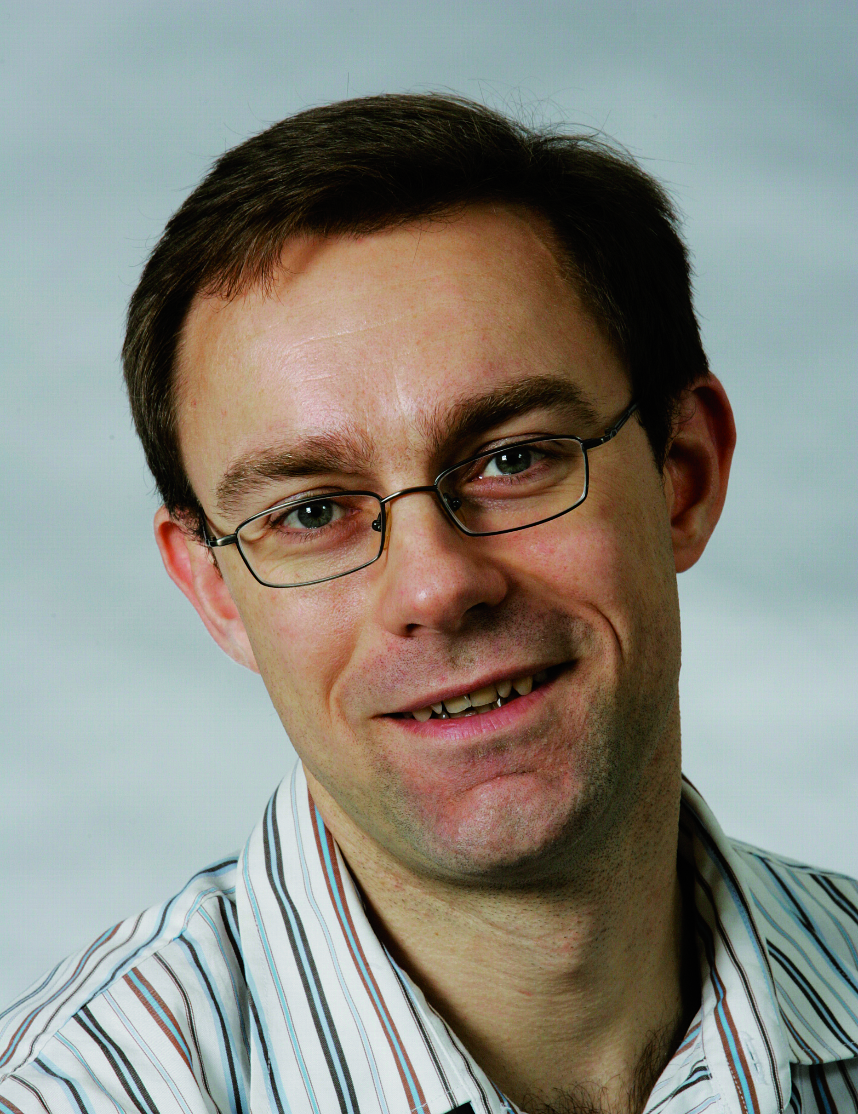
CV for Anker Degn Jensen (1966)
Researcher id: A-9505-2014
Degrees:
1991, M.Sc., Chemical Engineering, Department of Chemical Engineering, DTU.
1996. Ph.D., Department of Chemical Engineering, DTU.

Positions:
1996-1997 Research Assistant Professor, Department of Chemical Engineering, DTU; 1996-1997 Post Doc at Advanced Fuel Research Inc., Connecticut, USA; 1997-1999 Assistant Professor, 2000-2006 Associate Professor; 2007 Professor (Docent); 2007 – present, full professor of catalysis and chemical engineering, Department of Chemical Engineering, DTU.

Research Area:
Experimental and theoretical reaction engineering, combustion, catalysis and particle technology. Recent focus has been on catalysis for energy and environmental applications.

Distinctions and awards:
Several Best paper awards at international conferences; Award from the foundation of His Royal Highness The Prince of Denmark (1997); Award from Danmarks Tekniske Universitets Fond for Teknisk Kemi (2002); Award from Reinhold W. Jorck og Hustrus Fond (2005, included a grant of 150.000 dkr)

Memberships of scientific committees, review, positions of trust (selected):
Editorial board of FUEL; Evaluator for the Danish Advanced Technology Foundation; Member of European Federation of Catalysis Societies; President for the Danish Catalysis Society; Reviewer for many scientific journals; Opponent at many PhD defenses.
Member of ATV (The Danish Academy of Technical Sciences).

ISI journal publications (WoS): 122; Citations: 1993; H.index: 25; Other publ.: Many reports; Patents accepted by DTU: 1
Books: Clement, Fangel, Jensen, Thomsen, Kemiske enhedsoperationer, Polyteknisk Forlag, 2004.

Supervision of PhDs:
29 PhDs completed and 10 ordinary PhDs ongoing.

Teaching and Education activities:
Teaching bachelor (28020, 28140), master (28242), PhD and continiung education at DTU.

Grants, 2008 – present (ongoing or finished in 2008 or later):
PSO project: Hydrocarbon selective catalytic reduction (4 mio kr); UNIK project: Catalysis for Sustainable Energy (11 mio kr);DSF project: Nanoparticles for catalysis (9,5 mio kr); DSF project: Green (WP2 and WP6) (4+3 mio kr); Advanced Technology Foundation: B21st (7,5 mio kr); Next generation diesel exhaust gas cleaning (20 mio kr).DSF project: H2CAP(17,9 mio kr).

Research collaboration with industry, 2008 – present:
Haldor Topsøe A/S, Dong Energy A/S, Vattenfall A/S, Novozymes A/S, FL Smidth A/S

10 selected publications:

Castellino, F., Rasmussen, S.B., Jensen, A.D., Johnsson, J.E. and Fehrmann, R. ‘Deactivation of vanadia based commercial SCR catalysts by polyphosphoric acids’, Applied Catalysis B: Environmental, 2008, 83, pp. 110-122.

Christensen, J.M., Mortensen, P.M., Trane, R., Jensen, P.A. and Jensen, A.D. ’Effects of H2S and process conditions in the synthesis of mixed alcohols from syngas over alkali promoted cobalt molybdenum sulfide’, Applied Catalysis A: General, 2009, 366, pp. 29 43.

Hede, P.D., Bach, P. and Jensen, A.D. ‘Batch top spray fluid bed coating: Scale up insight using dynamic heat and mass transfer modelling’, Chemical Engineering Science, 2009, 64, pp. 1293 1317.

Heiredal, M.L., Jensen, A.D., Thøgersen, J.R., Frandsen, F.J., Friemann, U. ’ Pilot-Scale Investigation and CFD Modeling of Particle Deposition in Low-Dust Monolithic SCR DeNOx Catalysts’, AIChE J., 2013, 59, pp. 1919–1933.

Høj, M., Linde, K., Hansen, T.K., Brorson, M., Jensen, A.D., Grunwaldt, J.-D., ’Flame spray synthesis of CoMo/Al2O3 hydrotreating catalysts’, Applied Catalysis A: General., 2011, 397, pp. 201–208.

Jensen, A. and Johnsson, J.E. ‘Modelling of NOx Emissions from Pressurized Fluidized Bed Combustion-A Parameter Study’, Chem. Eng. Sci., 1997, 52, pp. 1715-1731.

Jensen, A., Dam-Johansen, Wojtowicz, M.A. and Serio, M.A. ‘A TG-FTIR Study of the Influence of Potassium Chloride on Wheat Straw Pyrolysis’, Energy and Fuels, 1998, 12, pp. 929-938.

Mortensen, P.M., Grunwaldt, J.-D., Jensen, P.A., Knudsen, K.G. and Jensen, A.D. ‘A review of catalytic upgrading of bio-oil to engine fuels’, Applied Catalysis A: General, 2011, 407, pp. 1– 19.

Qin, K., Lin, W., Jensen, P.A., Jensen, A.D. ’High-temperature entrained flow gasification of biomass’, Fuel, 2012, 93, pp. 589–600.

Studt, F., Abild-Pedersen, F., Wu, Q., Jensen, A.D., Temel, B., Grunwaldt, J-D. and Nørskov, J.K. ’CO hydrogenation to methanol on Cu–Ni catalysts: Theory and experiment’, J. Catalysis, 2012, 293, pp. 51–60.

Patents:
Deactivation-resistant catalyst for selective catalyst reduction of NOx. / Jensen, Anker Degn (Inventor); Castellino, Francesco (Inventor); Rams, Per Donskov (Inventor); Pedersen, Jannik Blaabjerg (Inventor); Putluru, Siva Sankar Reddy (Inventor). Patent No.: WO 2011073396. Jun 23, 2011.

